**TECHNICAL TRAINING**

**PROJECT REPORT**

**ST. ANDREW’S INSTITUTE OF TECHNOLOGY AND MANAGEMENT**



**Submitted To: Submitted by:**

**SANGAM BAA**

**229135**

**BCA 1ST Year**

**SEC:B**

**CONTENTS**

**1. ACKNOWLEDGEMENT**

**2. WEB DEVELOPMENT CERTIFICATE**

**3. SOURCE CODE**

**4. OUTPUT**

**5. CONCLUSION**

**6. BIBLIOGRAPHY**

**ACKNOWLEDGEMENT**

I would like to express my gratitude to my Web Development teacher Mr. Garvit Verma for his able guidance and support in completing my project.

I would also like to extend my gratitude to The Director sir for providing me with the qualified facility.

Date:

30/11/2022 Garvit Verma

**WEB DEVELOPMENT CERTIFICATE**

**This is to certify that SANGAM BAA students of BCA 1st SEM ROLL NO. 229135 has successfully completed the project work on topic website designing using HTML & CSS under the guidance of GARVIT VERMA (Technical Trainer).**

**This work is originally done by him. We wish him good future ahead.**

**Name and signature of Head of Development:-**

**Dr. Ankita Sharma ____________________**

**Name and signature of technical Trainer:-**

**Mr. Garvit Verma _____________________**

**SOURCE CODE**

**HTML:**

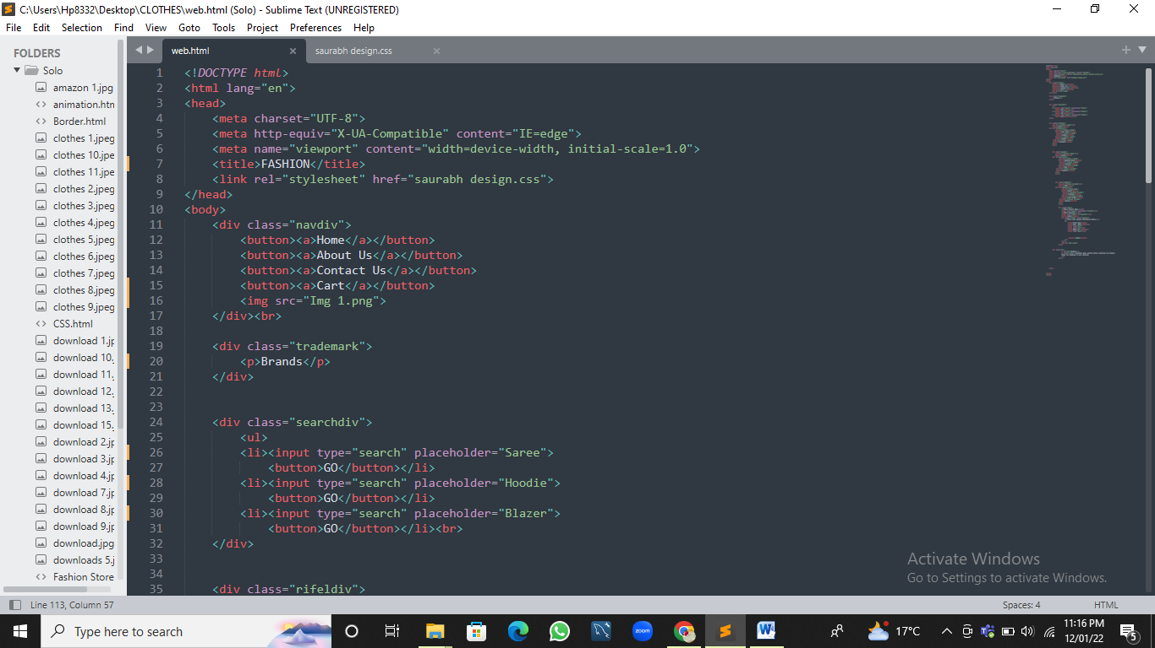

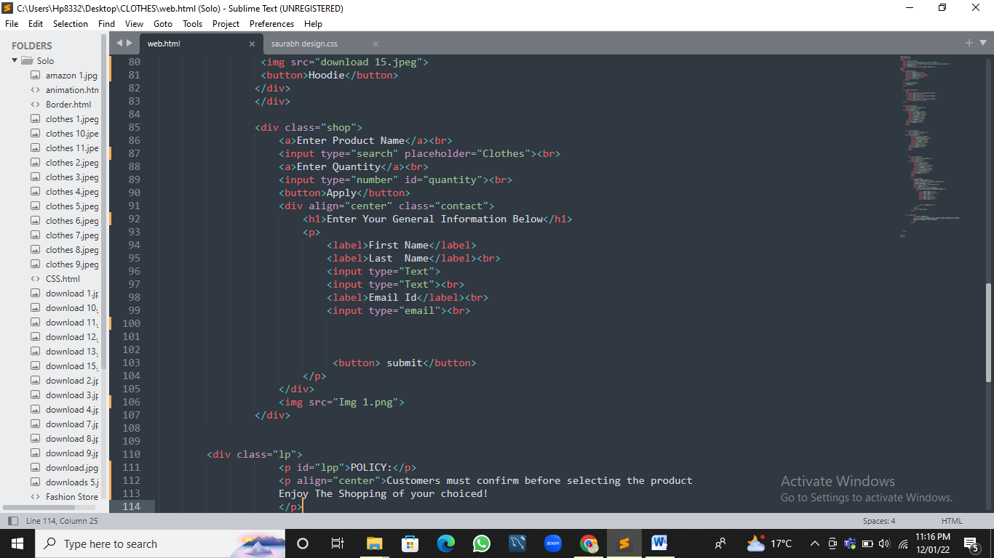

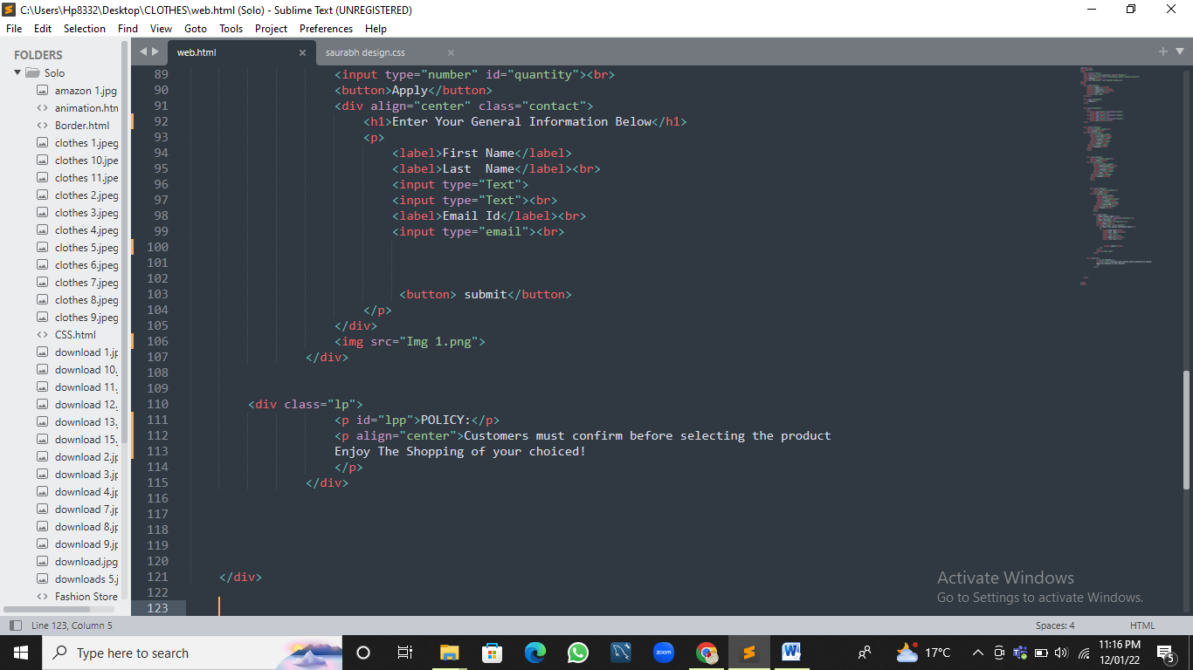

**CSS:**

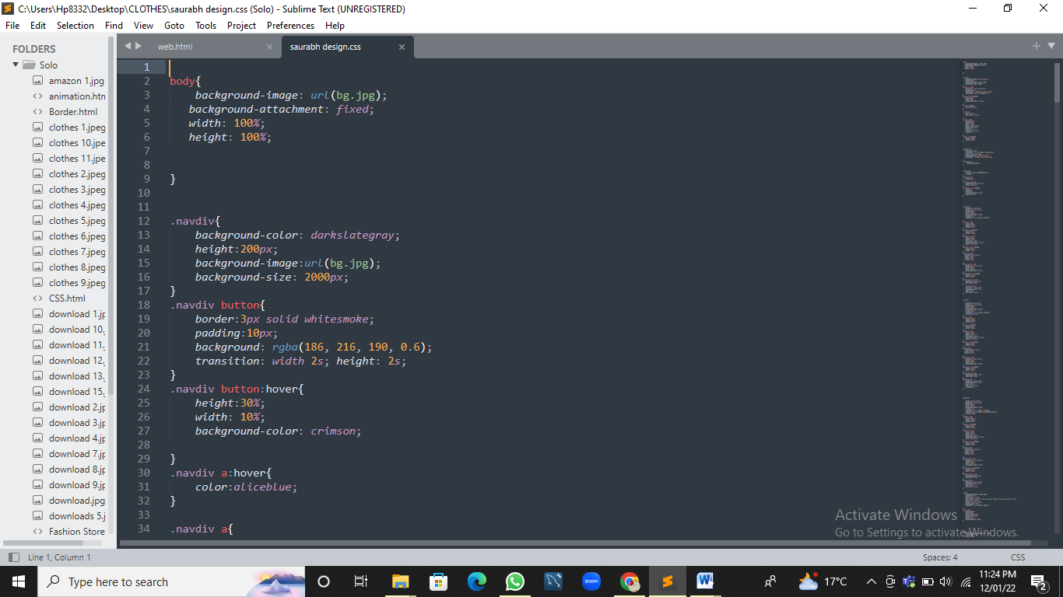

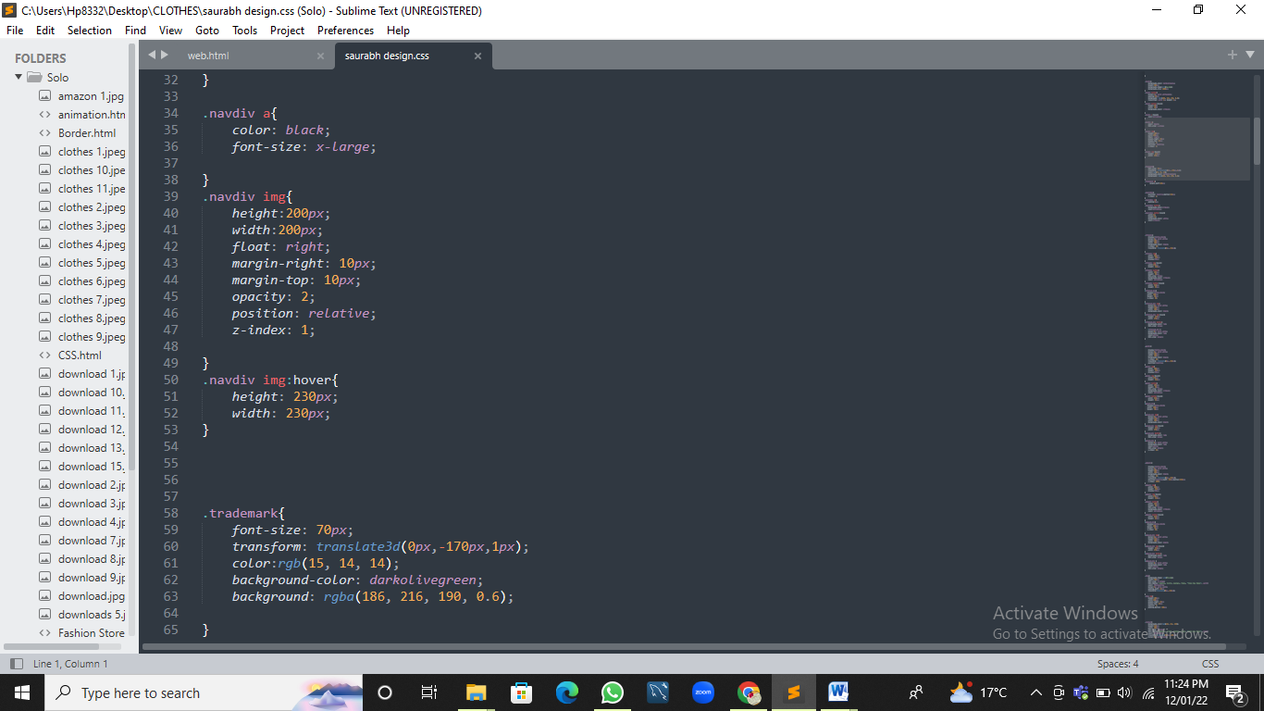

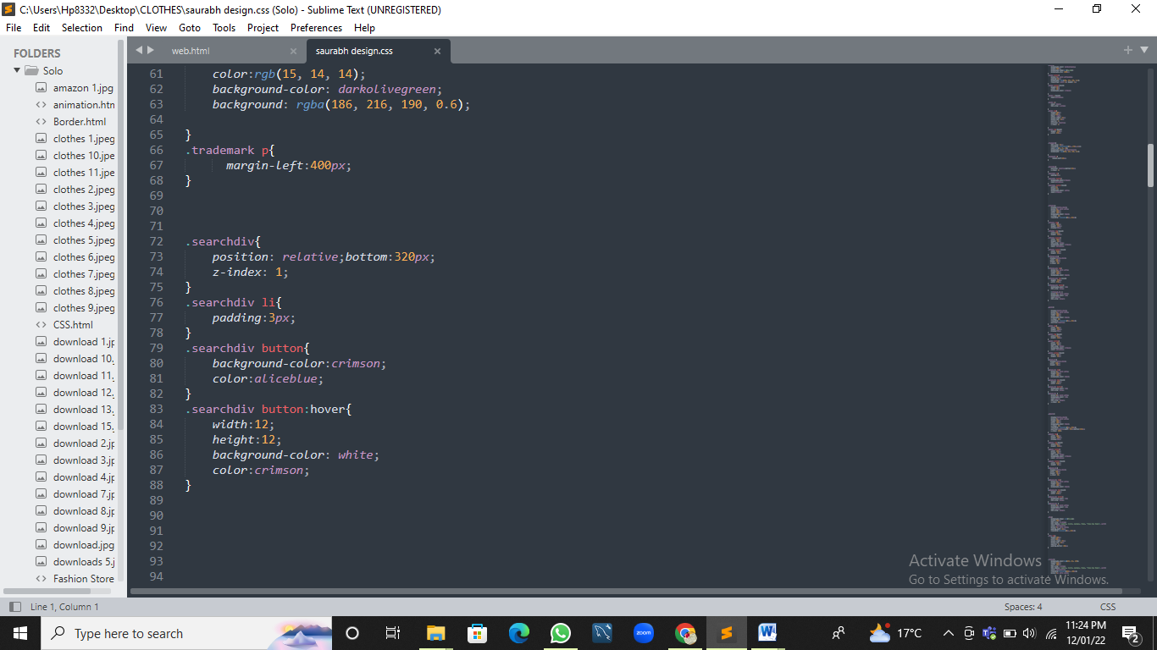

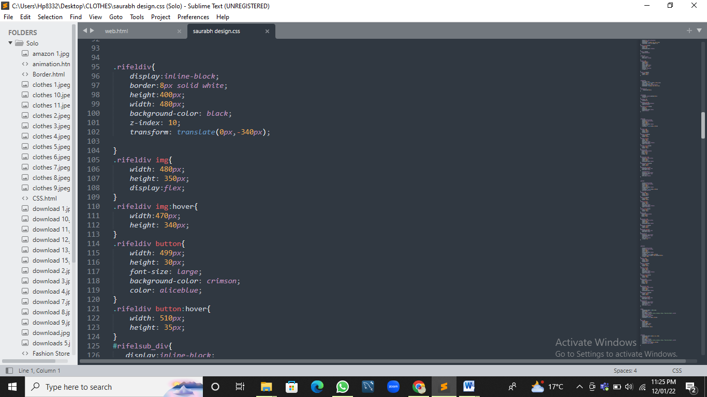

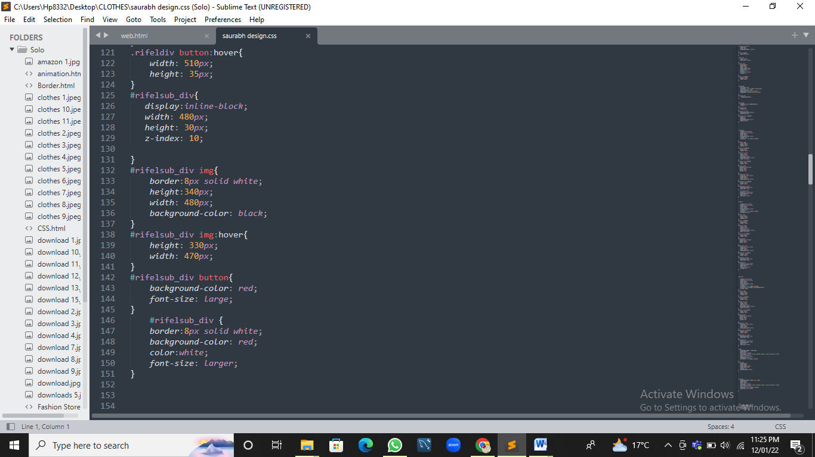

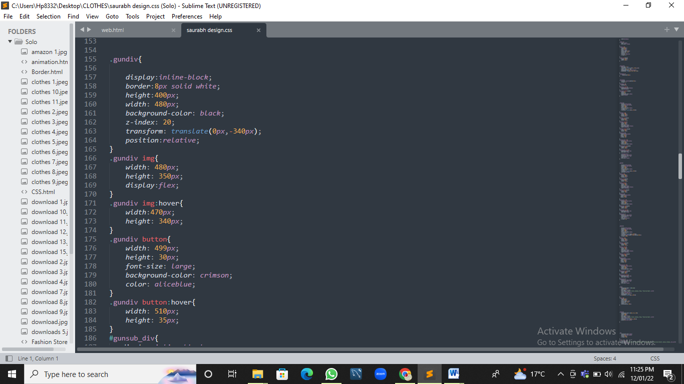

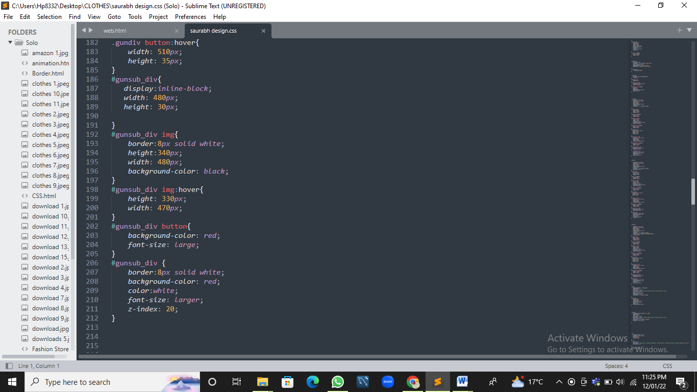

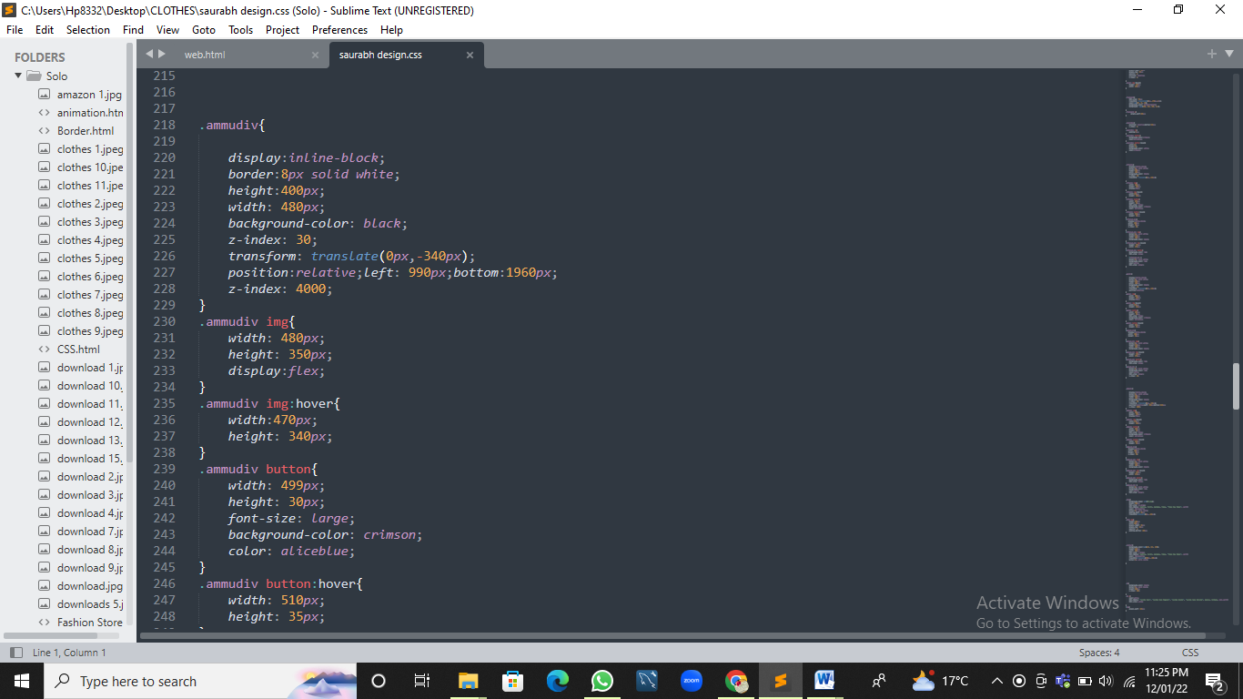

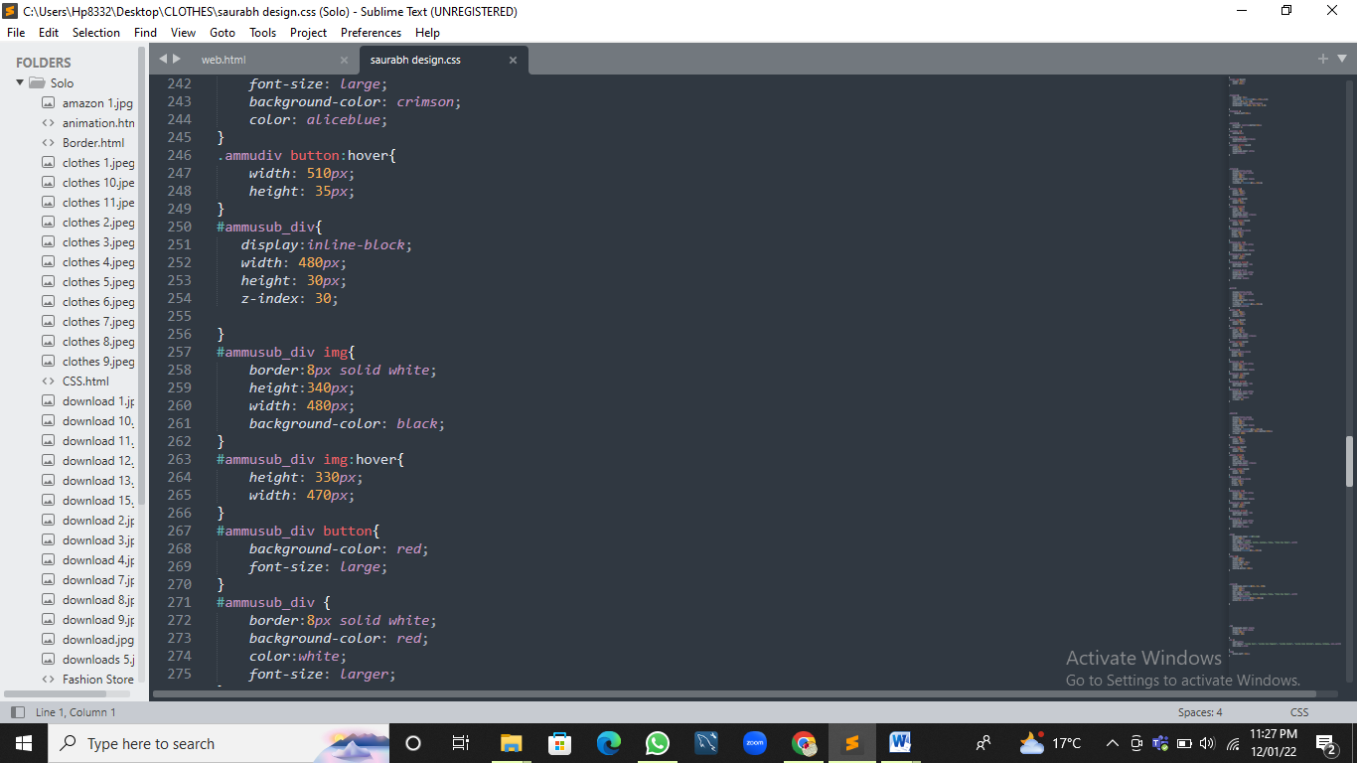

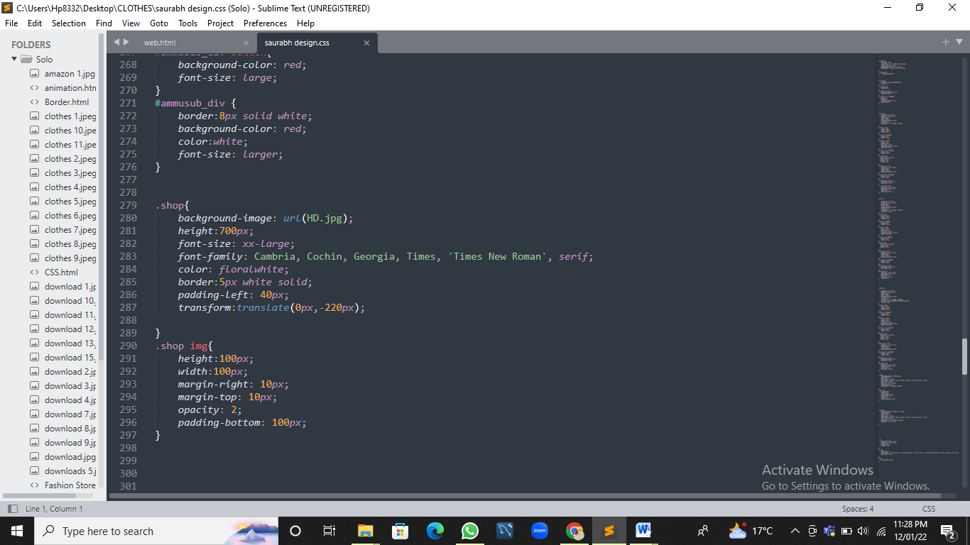

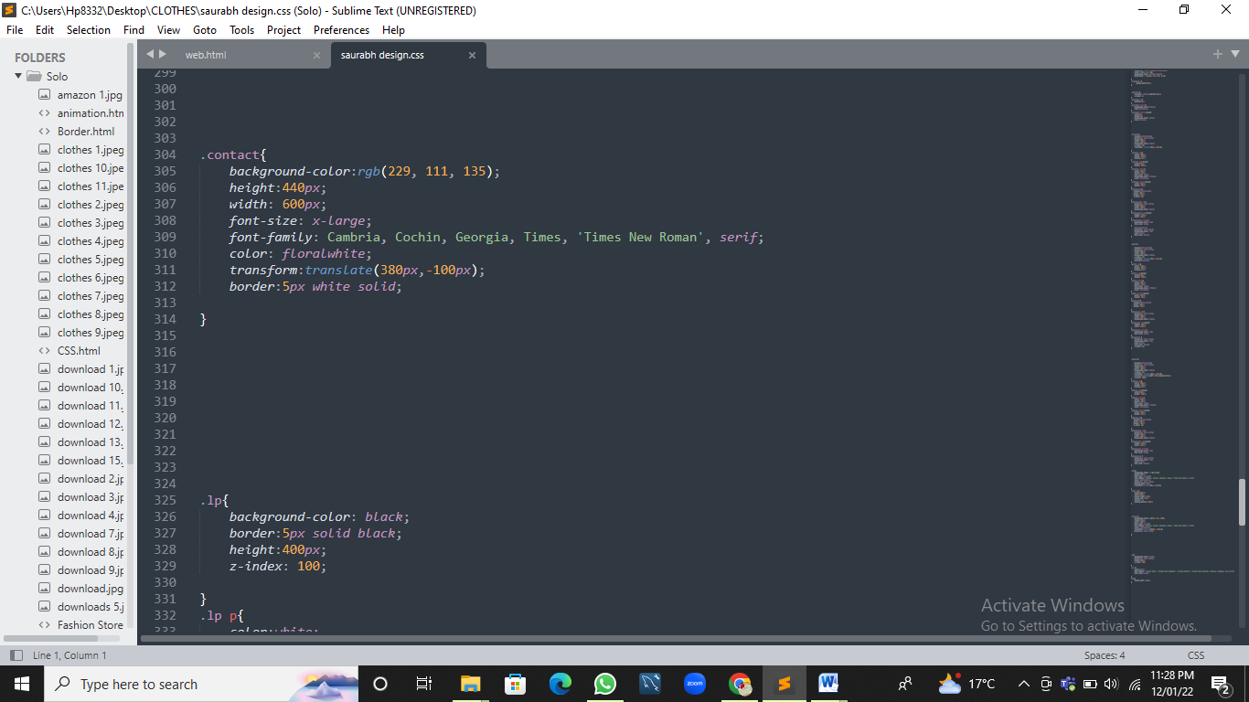

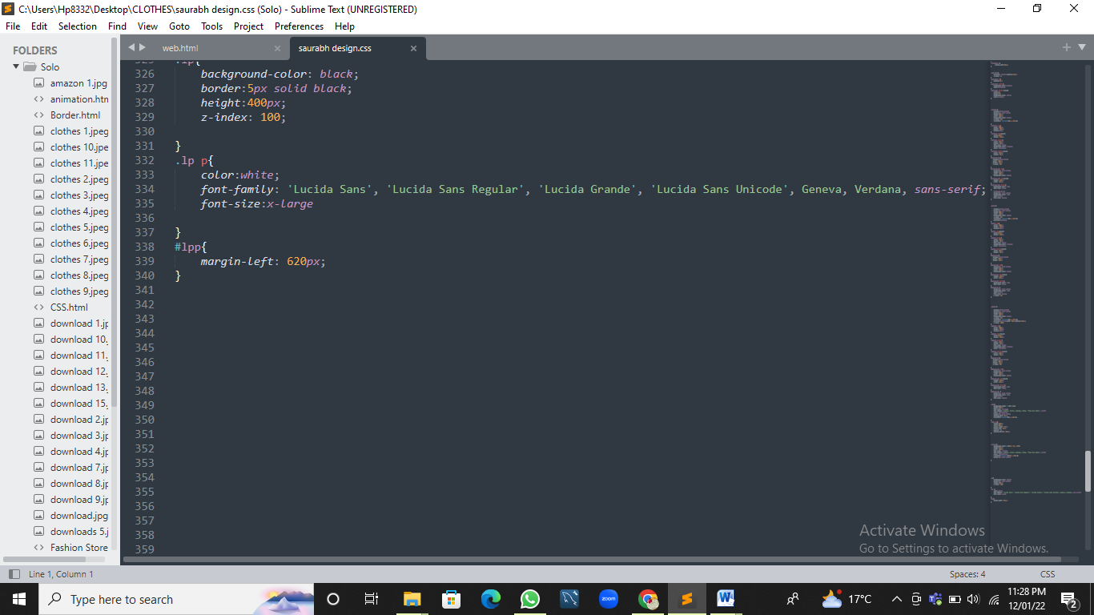

**OUTPUT**

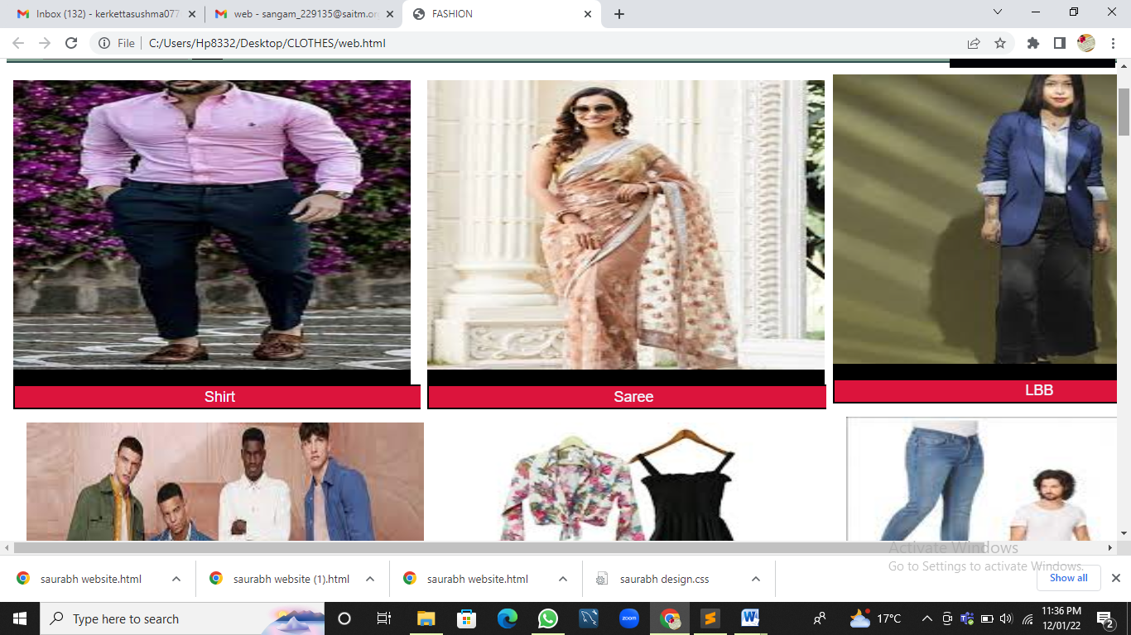

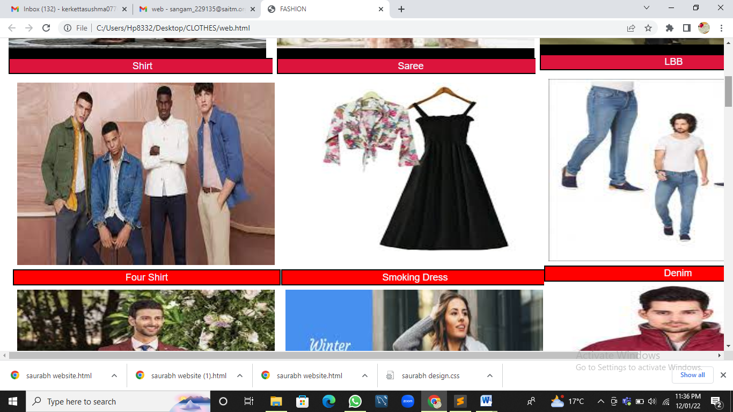

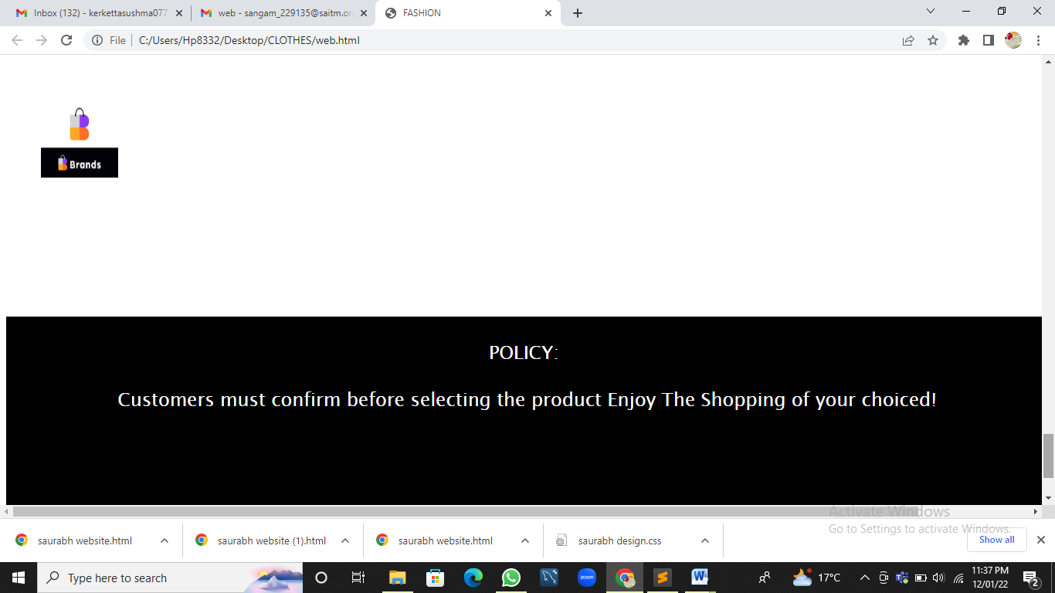

**CONCLUSION**

This project has been a useful experience as I have gained knowledge and new skills for Web Development.

I have completed this project with good impressions and experiences.

**BIBLIOGRAPHY**

**1.** [**www.w3schools.com**](http://www.w3schools.com)

**2.** [**www.google.co.in/imghp**](http://www.google.co.in/imghp)

**3. Pait3d(remove bg)**